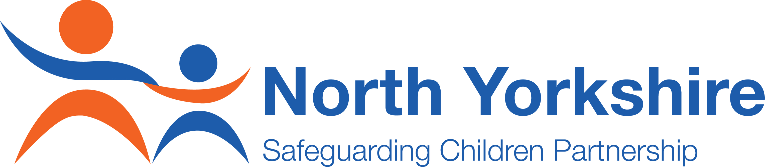
All Schools in North Yorkshire

All Schools in North Yorkshire | Room SB216, South Block
All Schools in North Yorkshire | County Hall, Northallerton
All Schools in North Yorkshire | North Yorkshire, DL7 8AE
12 November 2020

Dear Headteacher/Chair of Governors/Management Committees/Proprietors,

Safeguarding Audit for Schools 2020-2021

I hope this letter finds you well in these challenging times.

Schools are, as you are all to aware, key organisations providing services for children and young people. They play a pivotal role in their communities, promoting the wellbeing of children and young people and ensuring that adequate and appropriate safeguarding arrangements are in place. There are many demands on schools to safeguard children and young people which are identified in Working Together to Safeguard Children (2018), Keeping Children Safe in Education (2020) and other key pieces of legislation and statutory guidance. The CV19 pandemic has of course brought still further challenges, and we are acutely aware that this is so.

In response to the safeguarding requirements on you as a school, the North Yorkshire Safeguarding Children Partnership (NYSCP) whose Executive I chair, is undertaking an assessment of the safeguarding arrangements within all schools (maintained, academies, free, independent and special school, for both primary and secondary education) across North Yorkshire. The School Safeguarding Audit 2020/2021 is being undertaken in accordance with the functions of the NYSCP and I must emphasise that because they are Relevant Agencies held to account by NYSCP under the statutory guidance re-issued in 2018, all schools are required to comply with the audit.

The purpose of the audit is to:

- Provide schools with an opportunity to review, evaluate, and update their safeguarding arrangements as part of their continuous self-assessment, identifying good practice and highlighting areas to be developed
- Assist schools in developing an action plan to address any areas for improvements
- Assist in the monitoring of improvements to safeguarding arrangements by the Board of Governors/Management Committee or Proprietors, Headteacher and Designated Leads; and
- Assist schools in the collation of evidence for future inspections
- Help schools to identify and record their level of compliance with statutory requirements outlined in Working Together (2018), Keeping Children Safe in Education (2020) and Statutory Guidance for the Early Years Foundation Stage (2017)
- Provide the NYSCP with both an assurance of the good work we know is carried out by schools every day to ensure the safety and wellbeing of pupils and adults in and connected to the school, and the level of compliance with statutory requirements.

You will see that the audit tool attached has been updated changed since the tool was last used in the School Safeguarding Audit 2018/2019, responding to new requirements arising from changes in legislation and guidance.

For each question, schools are requested to provide a self-assessment of their level of compliance based on a grading system, together with any supporting evidence they can identify for the arrangements they have in place. Please note that the audit tool identifies the meanings of each grading for compliance. For more information see the accompanying guidance document when completing the audit.

Completed audit tools must be submitted electronically, in the Excel format provided. Please do not submit copies in other formats, e.g. on paper or as a PDF. Returns should be sent to nyscp@northyorks.gov.uk no later than Wednesday, 31 March 2021. Prior to submission the audit should be approved by the school’s Board of Governors, Management Committee or Proprietors. The extended timeframe for the audit is to ensure your school has sufficient time to enable a robust process of review to take place, engaging key staff and governors prior to governing board approval.

If a school is part of a federation or multi-academy trust, an individual response must be submitted for each school within North Yorkshire that has its own Unique Reference Number. Please note that we cannot accept Safeguarding Reports used to provide assurance to Governors, Trustees, Proprietors, etc. or audits in other formats as evidence of compliance with the audit.

Action plans resulting from the audit should be managed in accordance with the school’s governance procedures and remain the responsibility of the Board of Governors, Management Committee or Proprietors to progress.

Following the completion of the audit, a report will be provided to the NYSCP regarding the current safeguarding arrangements within schools across North Yorkshire. Individual school arrangements will not be identified in this report. A copy of the Executive Summary of this report and any key learning points arising from the audit will be shared with all schools. In addition, the information provided will be used by the Partnership to identify how schools can be supported, and will advise the NYSCP’s Learning and Improvement Subgroup and Education Focus Group for identification of future priorities and training needs.

If you have any queries regarding the audit you may contact Haydn Rees Jones, NYSCP Policy and Development Officer by email at haydn.reesjones@northyorks.gov.uk.

I would also like to inform you that as well as visiting the North Yorkshire Safeguarding Children Partnership’s website at www.safeguardingchildren.co.uk for up to date news, procedures, practice guidance and information you can also follow us on Twitter @nyscp1 or https://twitter.com/NYSCP1. I would also urge you to sign up for the NYSCP e-Bulletin by clicking here.

Yours sincerely,

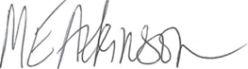

Dr Maggie Atkinson
Chair of the NYSCP Executive and Independent Scrutineer

